Reverse Integer
Platform: Leetcode
Language: C
Module 4, Question 6

Problem Link
https://leetcode.com/problems/reverse-integer/

Problem Statement
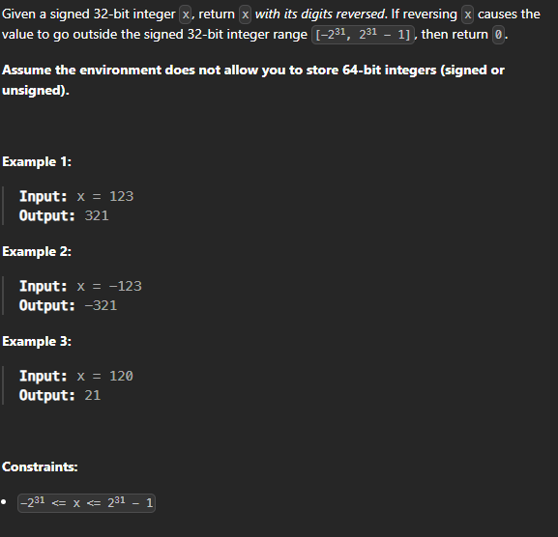

C Code
int reverse(int x) {
long long rev = 0;
while (x != 0) {
rev = rev * 10 + x % 10;
x /= 10;
}
// if the result doesn't fit in a 32-bit int, return 0
if (rev > 2147483647LL || rev < -2147483648LL)
return 0;
return (int)rev;
}

Screenshot of Successful Submission



